**A Project Report**

**On**

**Movie Recommendation System**

***Submitted in partial fulfillment of the***

***requirement for the award of the degree of***

**MASTER OF COMPUTER APPLICATION**

DEGREE

Session 2024-25

in

Master of Computer Application

By

Naman Kumar Maurya(23SCSE2030605)

Sejal Verma(23SCSE2030751)

Ravi Kumar Sah(23SCSE2030619)

Under the guidance of

Mr. Akhilesh Kumar Singh

**SCHOOL OF COMPUTER APPLICATIONS AND TECHNOLOGY**

**GALGOTIAS UNIVERSITY, GREATER NOIDA**

**INDIA**

**May, 2025**

**SCHOOL OF COMPUTER APPLICATIONS AND TECHNOLOGY**

**GALGOTIAS UNIVERSITY, GREATER NOIDA**

# CANDIDATE’S DECLARATION

I/We hereby certify that the work which is being presented in the project, entitled **“MASTER OF COMPUTER APPLICATION”** in partial fulfillment of the requirements for the award of the MCA (Master of Computer Application) submitted in the School of Computer Applications and Technology of Galgotias University, Greater Noida, is an original work carried out during the period of August, 2024 to Jan and 2025, under the supervision of Dr Akhilesh Kumar Singh Department of Computer Science and Engineering/School of Computer Applications and Technology , Galgotias University, Greater Noida.

The matter presented in the thesis/project/dissertation has not been submitted by me/us for the award of any other degree of this or any other places.

Naman Kumar Maurya (23SCSE2030605)

Sejal Verma (23SCSE2030751)

Ravi Kumar Sah(23SCSE2030619)

This is to certify that the above statement made by the candidates is correct to the best of my knowledge.

Mr. Akhilesh Kumar Singh

Assistant Professor

## SCHOOL OF COMPUTER APPLICATIONS AND TECHNOLOGY

## GALGOTIAS UNIVERSITY, GREATER NOIDA

## CERTIFICATE

This is to certify that Project Report entitled “Movie Recommendation System” which is submitted byNaman Kumar Maurya in partial fulfillment of the requirement for the award of degree MCA in Departmentof School of Computer Applications and Technology, Galgotias University, Greater Noida, India is a record of the candidate own work carried out by him/them under my supervision. The matter embodied in this thesis is original and has not been submitted for the award of any other degree.

**Signature of Examiner(s) SignatureofSupervisor(s)**

Date: May, 2025

Place: Greater Noida

**TABLE OF CONTENTS**

**Content Page No.**

List of Figures -----------------------------------------------------------------05

List of Abbreviations --------------------------------------------------------- 06

Acknowledgement ----------------------------------------------------- 07

**Chapter 1:**

Abstract ------------------------------------------------------------------ 08

Introduction ------------------------------------------------------------- 09

**Chapter 2:**

Literature Survey ------------------------------------------------------ 18

**Chapter 3:**

Software Requirement Specification ----------------------------- 22

**Chapter 4:**

System Analysis and Design --------------------------------------- 27

**Chapter 5:**

Implementation and Result ----------------------------------------- 24

**Chapter 6:**

Conclusion -------------------------------------------------------------- 40

**Chapter 7:**

Reference --------------------------------------------------------------- 42

**LIST OF FIGURES**

Figure 1: Architecture of Content Based Approach

Figure 2: Project Flow Diagram

Figure 3: Architecture of the whole Project

Figure 4: Use-case Diagram

**LIST OF ABBREVIATIONS**

KNN K- Nearest Neighbor

DBSCAN Density-Based Spatial Clustering of Applications with Noise

EDA Exploratory Data Analysis

RMSE The Root Mean Squared Error

**Acknowledgement**

I would like to thank and express our gratitude to our Project supervisor Dr. Akhilesh Kumar Singh for the opportunity that he provided us with this wonderful project “**Movie Recommendation System**”. The outcome would not be possible without his guidance. This project taught me many new things and helped to strengthen concepts of Machine Learning. Next, I would like to express my special thanks to the Lab Assistant for cordially contacting us and helping us in finishing this project within the specified time. Lastly, I would like to thank my friends and parents for their help and support.

**CHAPTER 1**

**ABSTRACT**

Recommendation systems have significantly changed the way we look for items of interest today. The technique applied here tries to predict user preferences using an information filtering technique that improves the user experience through timely and pertinent recommendations. In particular, movie suggestions are vital for enhancing interpersonal relationships since they may provide users with entertainment options based on their tastes or the current popularity of films. Data filtering systems often use these to help people locate products or content that meet their needs by going through large databases and making recommendations on what to buy or watch. These filtering systems, at times referred to as recommender systems, recommendation engines, or platforms, are designed to predict how a user might rank or favor an item. They are mainly used in the business sector. The primary purpose of this project is to produce a content based model for film recommendations that involve cosine similarity and vectorization to provide the consumer with general recommendations regarding the popularity of the films.

Keyword: - Content-based Filtering, Vector similarity, Hybrid approach, Movie Recommendations, Text to vector

**INTRODUCTION**

Nowadays, peoples some times feel overwhelmed with the amount of informationin this world, which can be easily perceived as the integral part of a person's everyday life- internet.

So if you want to find some lodging place or research new investment possibilities, then the overwhelming variety of data available can overwhelm a person.

In order to help customers overcome such an "information flood," many companies established recommendation systems. Due to the complexity and the vast number of real-world applications, recommendation systems have been a subject of intense research for decades.

Many online platforms have used these strategies, such as Amazon.com for books, MovieLens.org for movies, and CDNow.com (now part of Amazon.com) for music CDs.

The success of online retailers like Amazon and Netflix can be credited in large part to recommendation algorithms, which have become integral components of their platforms.

A list of some of the earnings made by these businesses is shown below:

|  |  |
| --- | --- |
| Netflix | 2/3rdofthemovieswatched arerecommended |
| GoogleNews | recommendationsgenerate38%moreclick-troughs |
| Amazon | 35%salesfromrecommendations |
| ChoiceStream | 28% of the people would buy moremusiciftheyfound what theyliked |

In order to consider the preferences of users, recommender systems provide recommendations that are most likely to be accepted by users. Users may choose to provide feedback during their may choose to provide feedback during their interactions or later sessions, which can be either open or implicit.

To make more personalized recommendations in subsequent interactions, the recommender system tracks user behaviors and feedback in its database.

Thise system have become an indispensable part of websites run by major online retailers such as Amozon.com and Snapdeal as well as services offering online movie rentals like Netflix due to their potential financial returns.

High-quality, personalized suggestions greatly improve the user experience. Online recommendation systems are in area singly used in a myriad of applications for giving users information that is personally relevant.

Generally, recommender systems can be divided into two main types:

1. A cooperative filtering approach

2. The content based filtering method

* **A cooperative filtering approach**

Collaborative Filtering (CF) is a widely used method in recommendation systems that filters information by leveraging the preferences of many users. It works on the principle that users who have agreed in the past tend to agree again in the future. Unlike content-based filtering, collaborative filtering does not rely on item metadata; instead, it uses user-item interactions, such as ratings, clicks, or likes.

Types of Collaborative Filtering

There are two main types of collaborative filtering.

1)User-Based Collaborative Filtering (UBCF).

2)Item-Based Collaborative Filtering (IBCF).

* **The content based filtering method**

Content-Based Filtering (CBF) is a recommendation technique that suggests items to users based on the characteristics of items and the user’s preferences. Unlike Collaborative Filtering, which relies on user interactions (e.g., likes or ratings), content-based filtering focuses on analyzing the content or features of the items themselves, such as genre, keywords, description, or tags.

The fundamental idea is: “If a user liked item A, they will probably like similar items B and C.”

How Content-Based Filtering Works

Feature Extraction:

Each item is described using a set of features. For example, a movie might be represented using genre, director, actors, or keywords.

User Profile Construction:

The system builds a profile for each user by analyzing the features of the items they have liked or interacted with. This profile reflects the user's preferences.

Similarity Matching:

The system calculates the similarity between the user profile and unseen items. The most similar items are recommended.

**PROBLEM STATEMENT**

Recommender systems are tools that aim to capture a user’s preferences and ratings, then suggest movies from a large dataset based on shared interests. These systems classify recommendations into different categories tailored to individual tastes and behaviors. The primary goal of such a recommendation system is to find and suggest content that aligns with a person’s interests, effectively creating a personalized experience—like a curated entertainment oasis for each user.

These systems take into account a wide range of factors that influence a user’s preferences. These may include viewing history, likes or ratings, watch duration, or even device type and session frequency. As a result, each user receives a unique set of recommendations, which are continuously refined as more behavioral data is collected.

AI-based algorithms play a vital role in this personalization. These algorithms evaluate a wide array of potential user behaviors and predict future interests. They are capable of modeling different scenarios, adjusting dynamically to match an individual's evolving preferences.

These predictions often rely on data from browser histories (such as Chrome, Opera, Firefox), prior interactions, and demographic traits. By processing massive datasets through predictive modeling and similarity metrics (like cosine similarity or collaborative filtering), a final shortlist of movies is generated from a dataset of thousands—resulting in smarter, user-specific recommendations.

**OBJECTIVE**

A movie recommendation system is a specialized software application designed to help users discover films they are likely to enjoy. It plays a significant role in modern digital streaming platforms by personalizing the user experience and reducing the effort needed to find interesting content. These systems operate by classifying users based on their interests, identifying content that aligns with these interests, and creating lists of recommended movies that each user is likely to appreciate. The core objective is to understand user preferences and recommend films using intelligent filtering techniques such as content-based filtering, collaborative filtering, and demographic filtering. Each of these techniques leverages different data sources and strategies to generate meaningful and relevant suggestions.

At the heart of the recommendation system lies the concept of understanding user behavior and preferences. This is typically achieved by analyzing user interaction data, such as movie ratings, watch history, likes or dislikes, and other implicit feedback like watch time or skips. By identifying patterns within this data, the system aims to predict what the user might enjoy watching next. The system not only makes use of the direct preferences of a user but also considers the preferences of users with similar tastes, which allows it to generate more diverse and accurate recommendations.

Content-based filtering is one of the primary approaches used in recommendation systems. It works by analyzing the features or attributes of the movies themselves. For example, each movie has metadata such as genre, director, actors, keywords, plot, and language. The system matches these features with the attributes of the movies that a user has previously liked or rated highly. Based on this comparison, it suggests new movies that share similar characteristics. This approach is user-centric and provides personalized recommendations without needing information about other users. However, content-based filtering can sometimes become too narrow in scope, continuously recommending similar types of movies and failing to introduce the user to diverse or unexpected content.

Collaborative filtering, on the other hand, is based on the assumption that people who liked the same movies in the past will like similar movies in the future. Instead of analyzing the content of the movies, this method focuses on user behavior. Collaborative filtering comes in two main types: user-based and item-based. In user-based collaborative filtering, the system finds other users with similar movie tastes and recommends movies that those similar users have liked. In item-based collaborative filtering, the system recommends movies that are similar to those the user has already liked, based on how users across the platform have interacted with them. This method is particularly powerful because it can uncover surprising recommendations that content-based filtering might miss. However, it depends heavily on large volumes of user data and can suffer from issues like data sparsity and the cold start problem, where new users or new movies lack sufficient data to make accurate predictions.

Demographic filtering is another technique used in recommendation systems. This method utilizes demographic information such as age, gender, occupation, and location to recommend movies. The basic idea is that people with similar demographic profiles tend to have similar interests. For example, teenagers may be more inclined to watch animated or superhero movies, whereas adults might prefer dramas or documentaries. While this approach is straightforward and useful when other forms of data are unavailable, it lacks personalization and relies on generalized assumptions that may not always be accurate for every individual.

To overcome the limitations of individual methods, many modern recommendation systems use a hybrid approach. Hybrid systems combine the strengths of content-based filtering, collaborative filtering, and demographic filtering to deliver more comprehensive and accurate recommendations. For instance, a hybrid model may use content-based filtering to identify a user’s preferences, collaborative filtering to find trends among similar users, and demographic filtering to fine-tune the results. This layered approach often results in better performance, increased diversity in recommendations, and improved user satisfaction.

As recommendation systems process more data, scalability becomes a major challenge. With millions of users and movies, the computational demands increase significantly. Collaborative filtering, in particular, can become resource-intensive as it involves computing similarities across a vast user base. Efficient algorithms, matrix factorization techniques, and distributed computing frameworks are often employed to address these challenges. Technologies like Hadoop and Apache Spark allow recommendation systems to handle big data more effectively and maintain real-time performance, even as the dataset grows.

Another common challenge is the cold start problem, where the system has insufficient data to make recommendations for new users or new items. To address this, the system may rely on hybrid techniques, incorporate additional metadata, or encourage users to provide initial ratings to jumpstart the recommendation process. In addition, systems can make use of implicit feedback—such as watch duration, clicks, or skipped content—to gather valuable information without requiring explicit user input.

As the dataset continues to grow, the recommendation system must evolve and adapt to deliver more accurate and diverse suggestions. Machine learning techniques such as clustering, classification, and deep learning models are increasingly being integrated into recommendation engines. These advanced methods can learn complex patterns in data and make predictions with higher accuracy. Natural language processing (NLP) techniques can also be used to analyze movie descriptions, plot summaries, and user reviews to enrich the data used for content-based filtering.

Furthermore, recommendation systems are increasingly incorporating real-time feedback loops. This means that as users interact with the system—by watching, skipping, or rating movies—the system updates its understanding of the user’s preferences and adjusts the recommendations accordingly. This dynamic behavior ensures that the system remains responsive to changing user tastes and habits over time.

In conclusion, movie recommendation systems play a crucial role in helping users discover content they love. By using content-based filtering, collaborative filtering, and demographic filtering—individually or in combination—these systems deliver personalized and engaging movie suggestions. Each technique brings its own strengths and challenges, but when integrated intelligently, they significantly enhance the user experience. As the volume of available data increases and technology advances, recommendation systems will continue to evolve, offering even more precise and diverse recommendations to users across the globe.

**SCOPEOFTHE PROJECT**

The goal of this project is to provide users with accurate and personalized movie suggestions by improving the quality, scalability, and accuracy of traditional recommendation systems. Instead of relying solely on pure methods like content-based or collaborative filtering, this project introduces a hybrid approach that combines sentiment analysis with content-based filtering.

Content-based filtering analyzes movie features—such as genre, actors, and director—and matches them with user preferences. This method functions by creating a profile for each user based on the characteristics of movies they have previously enjoyed. For instance, if a user frequently watches action movies starring a specific actor, the system identifies this pattern and recommends similar content. While this technique offers a high level of personalization, it has its limitations. It tends to recommend items similar to what the user has already watched, which can restrict diversity and novelty in recommendations. Moreover, it does not factor in how well-received a movie is by the broader audience, thereby potentially suggesting content that, while matching in characteristics, might have received poor reviews.

To address this, the system incorporates sentiment analysis, which examines user reviews and social media comments to understand how people feel about specific movies. This adds an emotional and qualitative dimension to the recommendation process. Sentiment analysis leverages natural language processing (NLP) techniques to determine whether a review is positive, negative, or neutral. By aggregating sentiment scores from multiple reviews, the system creates an emotional profile of a movie, reflecting the general public’s opinion. This approach helps the system distinguish between movies that are technically similar but differ significantly in audience reception.

By integrating sentiment scores with content-based similarities, the system can recommend movies that not only match a user’s taste but are also positively received by others. This fusion of objective metadata and subjective feedback results in a more holistic understanding of movie quality and appeal. For example, two films may share the same genre and lead actor, but one may resonate better emotionally with viewers due to its storytelling, direction, or soundtrack. Including sentiment analysis ensures that such nuances are captured, allowing the system to make more informed and emotionally intelligent suggestions.

This hybrid model improves personalization and helps avoid recommending poorly received content. It also addresses some of the key challenges faced by traditional systems, such as the cold-start problem and data sparsity. In collaborative filtering, the effectiveness of recommendations often depends on having a large volume of user interaction data, such as ratings or watch histories. However, for new users or newly added movies, such data might be insufficient. By combining content-based and sentiment-driven insights, the system can make viable recommendations even in the absence of extensive rating histories.

Additionally, it enhances scalability by reducing dependency on user rating matrices, which often suffer from data sparsity. This design allows the system to scale efficiently with growing datasets, as it does not require every user to rate every movie. Instead, it draws upon the rich information embedded in movie metadata and publicly available reviews to maintain recommendation quality. Furthermore, the sentiment analysis component can be continuously updated with new reviews and social media posts, keeping the recommendation engine current and responsive to emerging trends and audience preferences.

From a technical standpoint, the project uses a combination of machine learning algorithms, NLP models, and vector similarity calculations. Feature extraction from movie metadata and textual reviews forms the core of the data preprocessing stage. Once the features are extracted and sentiment scores are computed, the recommendation engine uses cosine similarity or other distance metrics to match user profiles with relevant movie vectors. The inclusion of sentiment scores as additional features enhances the dimensionality of movie representations, enabling more nuanced comparisons and better alignment with user preferences.

In the broader context, this project represents a shift towards more human-centric recommendation systems that not only understand what users like but also why they like it. As artificial intelligence continues to evolve, integrating emotional intelligence into machine learning applications is becoming increasingly important. In the realm of entertainment, where choices are deeply tied to mood, taste, and emotional responses, such advancements can significantly elevate user satisfaction and engagement.

Overall, the project aims to deliver smarter, more emotionally aware movie recommendations, making the system more robust and effective as it scales with larger datasets. It combines the strengths of structured metadata analysis and unstructured emotional feedback, bridging the gap between statistical relevance and human sentiment. This ensures that users receive recommendations that are not just logically appropriate but also emotionally satisfying, ultimately enhancing the overall user experience and trust in the recommendation system.

**CHAPTER 2**

**LITERATURE SURVEY**

Numerous recommendation systems have been created over time utilizing hybrid, content-based, or collaborative filtering techniques. Numerous machine learning and big data methods have been used in the implementation of these systems. K-Nearest Neighbor and K-Means Clustering Movie Recommendation System. A recommendation system gathers implicit or explicit information about a user's interests for various products, such as movies. The behavior of the viewer while viewing the films is used as an implicit acquisition in the creation of the movie recommendation system. An explicit acquisition, on the other hand, makes advantage of the user's past ratings or history when creating a movie recommendation system. Clustering is another supporting approach utilized in the creation of recommendation systems. The method of clustering involves arranging a collection of items so that those in the same clusters resemble one another more than those in other groups. To get the best-optimized outcome, KMeans Clustering and K-Nearest Neighbor are used to the movie lens dataset. Whereas the suggested approach gathers data and produces fewer clusters, the conventional technique scatters data, resulting in a high number of clusters. The suggested plan optimizes the movie recommendation process. Using a variety of criteria, the suggested recommender system forecasts the user's preferred film.

**Movie Recommendation System Using Content Based Filtering**

Depending on the characteristics of the user, content-based filtering algorithms are used. This approach is used when information about an item—such as its identity, location, or descriptions—is known but not about the user. Similar to collaborative techniques, it makes predictions about elements based on user knowledge while completely disregarding the contributions of other users. It frequently uses the user's supplied information, whether explicitly or implicitly. The engine gets more accurate when the user applies more content-based filtering procedures (like a content-based recommender) to the suggestions. Every user is presumed to function independently in a content-based recommendation engine. No information about other users is needed while analysing the item's qualities or attributes; instead, it searches for similarities across objects and recommends the option that is most comparable to other users. Every member of the cast, director, and writer, for instance, might be considered a feature if we looked at the film's content. Items that are significantly similar to the one that the user voted for are suggested to them.

**Sentiment Analysis:**

A Movie Recommendation System with Sentiment-Based Filtering extends a generic recommendation engine with user sentiment analysis from reviews or ratings. The idea is to merge content or collaborative filtering with Natural Language Processing (NLP) to evaluate how the users feel about the films they have watched. Layering this sentiment will allow recommendations to be generated not only from which movies were watched by the user but also by how they felt about those films.

**How does a Sentiment-Based Movie Recommendation Work?**

Collect Reviews: Gather user reviews, ratings, or comments about the films.

Sentiment Analysis: Apply NLP methods to analyze sentiment in the reviews as negative, neutral, or positive.

Profile Building: Build user profile detailing explicit ratings and sentiment inferred from reviews.

Recommendation Generation: Recommend movies by mixing movie properties (genres, directors and cast) and user sentiment against similar movies.

A survey of the several methods utilized in movie rec systems is included in the work by Mahesh et al.

[1]. It investigates deep learning techniques, hybrid approaches, content-based filtering, and collaborative filtering. A number of similarity metrics are looked at. It draws attention to how many businesses, including Facebook, LinkedIn, Pandora, Netflix, and Amazon, use recommendation systems. The review offers a concise synopsis of various approaches and strategies, providing insightful information for future recommendation system research. The study by Jiang et al.

[2] discusses movie recommendation systems' scalability and useful usage feedback. It suggests a user clustering-based recommendation system that is quite effective. The approach has a lower time complexity and performs similarly to conventional CF systems.

Rishabh and colleagues' study focuses on developing a movie recommender system using K Means Clustering and K Nearest Neighbour Algorithms.

[3] The dataset used is called MovieLens, and the system is operated using Python. We provide several machine learning concepts, tools, and techniques, including Content-Based Filtering, KNN, K-Means Clustering, and Collaborative Filtering. The architecture, process flow, and pseudocode of the proposed system are described. The results show that the recommended system outperforms the state-of-the-art techniques, with a best RMSE value of 1.081648. Recommender systems (RS), developed by Choudhury et al.

[4] tackle the issue of information overload, specifically in the context of movie suggestions. The four recommendation models—BPNN, SVD, DNN, and DNN with Trust—are compared. With the best accuracy of 83% and a low MSE of 0.74, the DNN with trust model is a good option for movie suggestions.

Sahu et al.

[5] propose a content-based movie recommendation system that takes into account a number of variables. A CNN deep learning model predicts the popularity of a film based on RS results, film ratings, and voting data.

The study's accuracy of 96.8% outperforms benchmark models. A collaborative filtering approach for movie suggestions that considers temporal effects is shown in the study by Behera et al.

[6] It outperforms leading models, according to examination of the Movielens dataset, with improvements of 1.35% and 1.28% on the ML-100K and 1M datasets, respectively.

The study by Gupta et al.

[7] uses cosine similarity in conjunction with K-NN algorithms and collaborative filtering. The strategy mitigates the drawbacks of content-based filtering by skilfully combining the advantages of both approaches. The precision obtained by using cosine similarity is comparable to that of Euclidean distance.

[8] present a novel graph-based model that considers geography, demographic information, and user similarities. The cold-start problem is resolved and suggestion reliability is increased by the use of Autoencoder feature extraction. Experimental results on the dataset show the effectiveness of the proposed method.

**CHAPTER 3**

# SOFTWARE REQUIREMENT SPECIFICATION

The detailed explanation of the specification of the hardware and software is involved in this chapter.

**Hardware Requirements**

* A PC with Windows or Mac OS
* Processor with 2.40GHz- 2.50 GHz speed
* Minimum of 4gb RAM

**Software Specification**

* Text Editor(VS code/Jupyter Notebook/ Google Colab)
* Python Libraries
* A web browser
* A working internet connection

**Software Requirements**

**Python libraries**

We require specific Python modules for analytics in order to compute and analyse the data. It is necessary to have packages like SKlearn, NumPy, pandas, Matplotlib, Flask framework, etc.

**SKlearn**: The project utilizes scikit-learn (sklearn), a powerful machine learning library in Python that includes a wide range of classification, regression, and clustering algorithms. These algorithms are essential for building and evaluating the performance of the movie recommendation system.

**Scikit-learn offers several key algorithms, such as:**

Support Vector Machines (SVM): Used for classification tasks, SVM helps in separating data into different categories by finding the optimal hyperplane.

**Random Forests:** A versatile and robust ensemble method used for both classification and regression. It works by constructing multiple decision trees and combining their outputs.

**Gradient Boosting:** A powerful technique for improving prediction accuracy by building models sequentially and minimizing errors at each step.

**K-Means Clustering**: Commonly used for segmenting users or movies into clusters based on similarity. This helps in identifying user groups with similar tastes.

**DBSCAN (Density-Based Spatial Clustering of Applications with Noise):** An advanced clustering method that is effective in discovering clusters of varying shapes and sizes, especially in noisy datasets.

Scikit-learn is fully compatible with NumPy and SciPy, two foundational libraries in Python for numerical and scientific computing. This compatibility allows smooth integration and efficient computation, making it ideal for data-driven projects like movie recommendation systems.

**NumPy**: NumPy is a versatile and foundational library in Python designed primarily for array manipulation. It provides a high-performance multidimensional array object called ndarray along with a rich collection of mathematical functions to efficiently operate on these arrays. NumPy enables fast numerical computations and forms the backbone of many scientific computing tasks in Python. Its optimized performance and broad functionality make it essential for handling large datasets, performing linear algebra, Fourier transforms, and random number generation within the Python ecosystem.

In contrast, Pandas is a highly popular library in data science, offering high-performance, easy-to-use data structures and analysis tools. While NumPy focuses on homogeneous multidimensional arrays, Pandas introduces a more flexible and expressive data structure called the DataFrame, which is essentially an in-memory, two-dimensional labeled table. DataFrames allow heterogeneous data types across columns, enabling efficient handling of structured data like time series, tabular datasets, and relational data. Pandas provides powerful features for data cleaning, manipulation, filtering, grouping, aggregation, and time-series analysis, making it indispensable for exploratory data analysis and preparing data before feeding it into machine learning models. Together, NumPy and Pandas complement each other by covering different aspects of scientific and data-driven computing in Python.

**Pandas**: Pandas is an open-source Python library built on top of the NumPy library. It extends NumPy’s capabilities by providing a rich set of data structures and operations specifically designed for manipulating and analyzing numerical data and time series. Pandas is especially popular because it makes importing, cleaning, and analyzing data straightforward and efficient.

The core data structures in Pandas, such as DataFrames and Series, allow users to work with labeled and heterogeneous data in a tabular format, which is more intuitive for many real-world datasets compared to NumPy’s homogeneous arrays. Pandas supports a wide variety of data manipulation tasks, including filtering, grouping, merging, reshaping, and time-series functionality, which are essential for data analysis workflows.

Because Pandas is built on top of NumPy, it inherits much of NumPy’s speed and performance efficiency, making it suitable for working with large datasets. This combination of ease-of-use and performance makes Pandas one of the most widely used libraries in data science, analytics, and scientific computing in Python.

**Flask:** Flask is a micro-framework for Python known for being lightweight and highly adaptable. Unlike larger web frameworks, Flask provides only a minimal core set of tools necessary to build web applications, without enforcing any specific project structure or including built-in components for everything. This minimalism gives developers the freedom to choose the libraries, tools, and architectures that best suit their project’s needs.

Because of its flexibility, Flask is ideal for small to medium-sized applications or when you want full control over the components you use. It supports routing, request handling, templating, and extensions, allowing you to add functionality like database integration, authentication, or RESTful APIs as needed. Flask’s simplicity and modularity make it popular for building web services, including APIs to serve machine learning models or recommendation systems, while keeping the development process straightforward and customizable.

**SciPy**: SciPy is an open-source scientific and technical computing library for Python that builds on top of NumPy. It provides a comprehensive collection of modules and functions tailored for a wide range of scientific and engineering tasks. Some of the core functionalities offered by SciPy include:

Optimization: Algorithms for finding minima, maxima, and roots of functions.

Linear Algebra: Advanced matrix operations, decompositions, and solvers beyond those available in NumPy.

Integration: Numerical integration techniques for calculating definite integrals.

Interpolation: Methods for estimating values between discrete data points.

Special Functions: Mathematical functions commonly used in physics and engineering.

FFT (Fast Fourier Transform): Efficient algorithms for computing Fourier transforms, important in signal processing.

Signal and Image Processing: Tools for filtering, transforming, and analyzing signals and images.

ODE Solvers: Solvers for ordinary differential equations used in modeling dynamic systems.

Overall, SciPy extends the numerical capabilities of Python, making it a vital library for complex scientific computations, simulations, and data analysis in various fields of research and engineering.

**CHAPTER 4**

**SYSTEM ANALYSIS AND DESIGN**

**System Architecture of Proposed System:**

**A**

**B**

**C**

**D**

**Recommend**

**Likes**

**Similar**

**Items**

**Fig 1: Architecture of Content Based Approach**

Content-based filtering in recommender systems builds a training model on the basis of a set of features and user knowledge so as to predict and recommend similar products to customers. It operates by recommending a product based on a previously known or characteristic knowledge of a product and the decisions made by the user. The recommender system builds a profile of the user based on accumulated information such as clicks, ratings, and likes from past interactions. The more the user interacts with the system, the better the future recommendations will be.

**Project Flow:**

Data

Pre- Processing

Add model to website

Deploy

Machine Learning Model

**Fig 2: Project Flow**

Initially data sets are loaded that are required to build a model. Data set that are required in this project are tmdb_credits.csv and tmdb_movies.csv all the data sets are available on Kaggle.com. Basically, three models are created using a content-based approach and then imported into a website using the Flask Python library used for creating web apps.

**Architecture:**

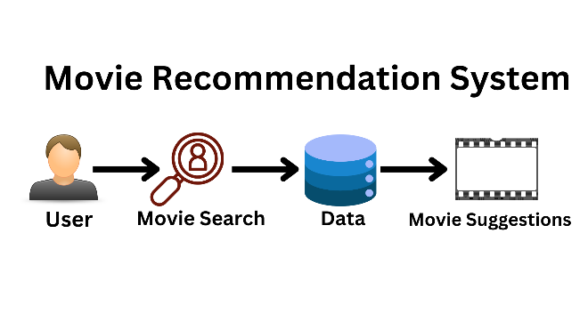

**Fig 3: Architecture of the whole project**

The architectural diagram of the Movie Recommendation System presents a streamlined flow that visually explains how a user’s input transforms into personalized movie suggestions. At its core, this system relies on a cycle of data interaction, processing, and delivery. It begins with a user initiating a movie search. This initial interaction is illustrated in the diagram by the icon of a person accompanied by a magnifying glass, symbolizing the user's curiosity or intent to find content. The simplicity of this visual cue is essential, as it abstracts the potentially complex set of actions a user might take—such as typing a movie name, selecting a genre, or simply clicking through a few options—into a universally understood symbol. This initiation by the user marks the starting point of the recommendation engine, which immediately triggers the data retrieval and filtering mechanisms of the system.

Following the user's action, the system proceeds to the data layer, represented in the diagram with a database icon. This is where all the critical information is stored and managed. The data accessed during this stage is extensive and multi-dimensional. It includes a combination of static metadata, such as the movie’s title, genre, cast, director, release date, language, synopsis, and ratings, along with dynamic behavioral data that evolves with user activity. This behavioral data could be in the form of user ratings, watch history, searches, likes and dislikes, and even the amount of time spent watching particular genres or actors. The data might also include reviews—both structured and unstructured—as well as inferred preferences extracted from interactions with the system over time.

To generate effective recommendations, the system must convert this raw data into something computationally meaningful. This is achieved through a process known as feature extraction or vectorization. Each movie, for example, can be represented as a feature vector that encodes various attributes. For instance, if genres are encoded using one-hot encoding, a movie tagged as Action and Sci-Fi would have a feature vector indicating these genres. Textual content such as plot summaries or user reviews might be converted using techniques like TF-IDF or word embeddings, which can highlight the importance of certain keywords or themes across a large dataset. Similarly, user profiles are built by analyzing the common features in the content they interact with most frequently. This step ensures that the system not only stores data but understands patterns and preferences.

Once the features are extracted, the heart of the system—the recommendation engine—comes into play. This is where the actual decision-making happens. The diagram implies the involvement of intelligent algorithms, which could include content-based filtering, collaborative filtering, or hybrid models. Content-based filtering focuses solely on comparing the attributes of movies the user has liked in the past to those of other available movies. For example, if a user shows a preference for science fiction films starring a particular actor or directed by a specific filmmaker, the system prioritizes recommending other movies sharing those characteristics. It measures similarity using mathematical methods such as cosine similarity or Euclidean distance between feature vectors. In practice, this means the system is constantly comparing the user’s profile against the database of movie profiles to find the most similar matches.

Collaborative filtering, although not the primary focus of this diagram, may also play a role in more advanced systems. This approach leverages the collective preferences of multiple users to generate recommendations. For instance, if users with similar watch histories to the current user rated a movie highly, it could be recommended even if it doesn’t align strictly with the user’s previously shown content preferences. However, content-based filtering remains particularly useful in cases where user data is limited or when privacy concerns discourage the use of other users' information.

After processing, the system generates movie suggestions tailored to the user's interests. This final step is depicted in the diagram using a film strip icon, a visual shorthand for movie output. These suggestions are not random but ranked based on how closely they match the user’s profile and preferences. The ranking can be influenced by many factors—similarity scores, user ratings, popularity, recency, or even diversity algorithms that ensure the recommendations are not too homogenous. The goal is to balance relevance with discovery, ensuring the user receives both expected favorites and potentially new, but related, experiences.

The simplicity of the diagram aids in understanding the system's logical progression. From user input, data access, and algorithmic analysis to final recommendation, each step is intuitively represented. The clean layout helps demystify the complex inner workings of machine learning models that operate behind the scenes. At the top of the diagram is the clear title “Movie Recommendation System,” which immediately informs viewers about the system being described. At the bottom, the caption “Fig 3: Architecture of the whole project” signals its function within a broader report or project, indicating that this diagram serves as a holistic snapshot of the recommendation pipeline.

Even though the diagram focuses on a high-level overview, it hints at a robust backend framework. The flow of data from the user's device to the database and back through the recommendation algorithm implies a layered software architecture. Typically, this might involve a front-end interface built using web technologies like HTML, CSS, and JavaScript, which communicates with a backend server—perhaps built with Python, PHP, or Node.js—that handles the business logic and data processing. The backend would in turn connect to a database—relational or NoSQL—storing both user data and movie metadata. Depending on the complexity and scale of the system, a machine learning module would handle real-time predictions or batch model updates using libraries like Scikit-learn, TensorFlow, or PyTorch.

Content-based filtering systems particularly benefit from continuous learning. As users interact with the system—by liking or disliking a recommendation, rating a movie, or skipping certain genres—the system updates their profile accordingly. This dynamic updating ensures that recommendations evolve alongside the user’s changing tastes. Moreover, the system could incorporate feedback loops where the relevance of past recommendations influences future model training, leading to better accuracy and user satisfaction over time.

Another critical aspect of the architecture is handling the cold start problem, which arises when a new user or movie enters the system without sufficient data. Content-based filtering mitigates this for new users by encouraging early interactions—such as rating a few favorite movies or selecting preferred genres—so that a preliminary profile can be built quickly. For new movies, having rich metadata ensures they can be recommended based on content similarity, even before user feedback accumulates. This highlights the importance of high-quality, structured metadata in the success of the entire recommendation process.

The architecture also implicitly supports personalization, which is key to user retention. Personalized recommendations not only increase engagement but also create a sense of value for the user. This level of customization, however, must be balanced with considerations of privacy and ethical data usage. Since content-based filtering primarily relies on individual user data rather than cross-user behavior, it offers a more privacy-conscious approach to recommendations.

Additionally, the system could be enhanced with explainability features that tell users why a particular movie was recommended—such as “Because you liked Interstellar” or “You watch many movies with time travel themes.” These explanations not only increase trust in the system but also encourage further interaction, creating a virtuous cycle of engagement and refinement.

In more sophisticated implementations, the architecture might expand to include additional modules like a real-time analytics engine, a batch model retraining scheduler, or even a user feedback analyzer that scans textual feedback using natural language processing. These modules would not be visually represented in a simplified diagram, but they are crucial in a production-level system. They ensure that the model remains accurate, responsive, and aligned with user expectations.

The overall architecture is modular and scalable. Each component—from user interface to recommendation engine—can be independently developed, tested, and improved. This modularity allows for easy upgrades, such as integrating deep learning-based recommenders, real-time personalization, or support for cross-platform data syncing. As the user base and data volume grow, the architecture can scale accordingly by adopting distributed databases, cloud storage, and parallel processing.

Ultimately, the architectural diagram of the Movie Recommendation System serves as a conceptual blueprint. It outlines the seamless flow of information and logic that drives one of the most engaging features of any digital content platform. It encapsulates the user’s journey from curiosity to discovery, showing how data, algorithms, and user interaction harmonize to deliver personalized cinematic experiences. This explanation, paired with the visual diagram, forms a comprehensive understanding of how modern recommendation systems work at both macro and micro levels, providing not just entertainment, but a deeper connection between users and the content they consume.

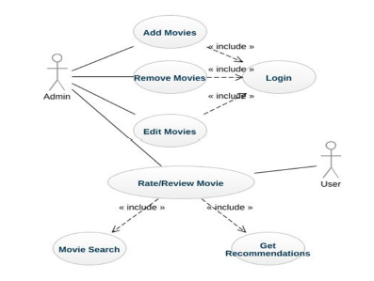**Use-case Diagram:**

**Fig4: Use-case Diagram**

The image displays a **Use-case Diagram** for a **Movie Recommendation System**, highlighting the interactions between different types of users (actors) and the system’s core functionalities (use cases). This diagram visually outlines what actions can be performed by users and administrators within the system.

There are two primary actors in the diagram:

1. **Admin** – Responsible for managing the movie database.
2. **User** – The end-user who interacts with the system to get movie recommendations.

### Admin Use Cases:

The **Admin** has access to multiple management operations:

* **Add Movies**
* **Remove Movies**
* **Edit Movies**

Each of these use cases includes a connection to **Login**, indicating that login authentication is mandatory for the admin to perform these actions. This ensures secure access control within the system.

### Shared Use Case:

Both **Admin** and **User** can perform the **Rate/Review Movie** action. This reflects a common functionality allowing any logged-in individual to submit feedback on movies.

### User Use Cases:

The **User** has access to:

* **Movie Search** – To look up movies of interest.
* **Get Recommendations** – To receive movie suggestions based on previous interactions or preferences.

Both of these use cases are included as part of the **Rate/Review Movie** use case, meaning that rating or reviewing a movie may trigger the recommendation engine or involve a search process to locate the movie.

### Diagram Notations:

* The **stick figures** represent users.
* The **ovals** indicate system functionalities or use cases.
* The **dashed arrows labeled «include»** represent that one use case depends on or includes the behavior of another use case.

The caption below the diagram reads **"Fig 4: Use-case Diagram"**, signifying its place within a structured project report. This diagram helps clarify the scope and functionality of the system, highlighting the different roles and actions that users can perform.

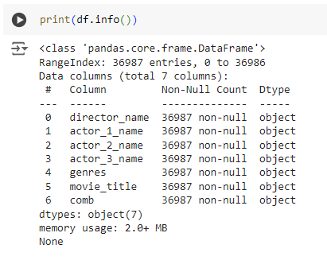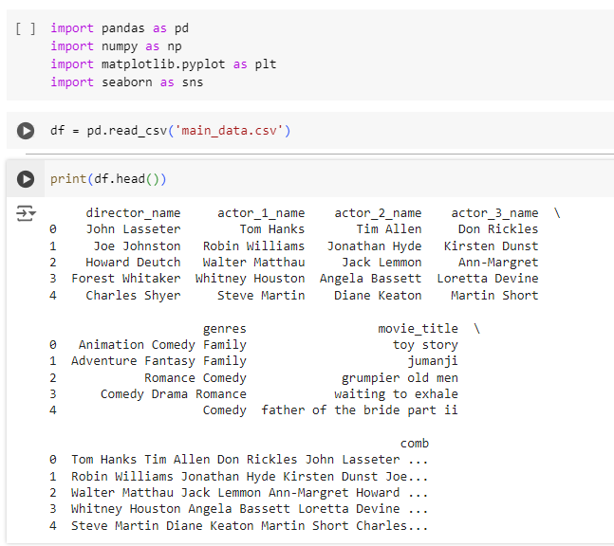Exploratory Data Analysis (EDA) of the final dataset gives some information regarding the available attributes:

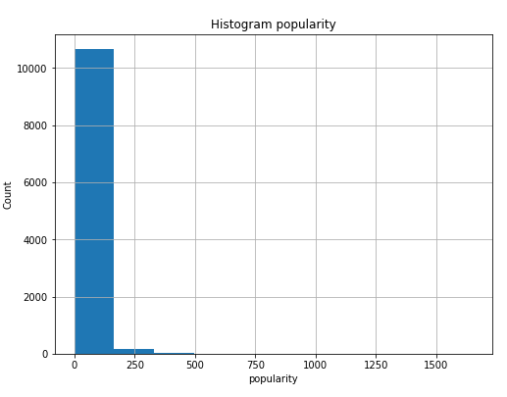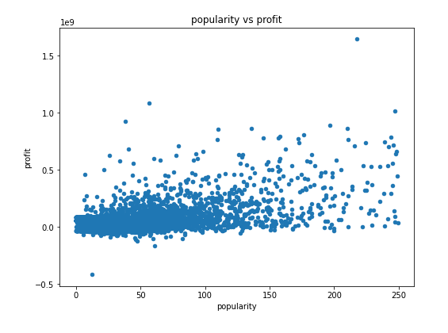From above observation it’s clear that Most of the popularity data lies between 0 to 200.

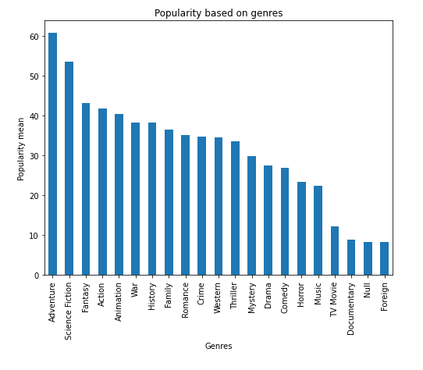Popular movies tend to earn more profit.

Adventure, Science Fiction, Fantasy, Action, Animation are the top 5 Genres which have top 5 popularity.

**CHAPTER 5**

# IMPLEMENTATION AND RESULTS

The Proposed System Makes Use of Different Algorithms and Methods for the implementation of Content based approach.

**Similarity Score:**

The given text discusses a numerical method used to measure the similarity between two items based on their textual content. This numerical value, referred to as a similarity score, ranges from 0 to 1, where a score closer to 1 indicates high similarity and a score closer to 0 suggests low or no similarity. This scoring mechanism is particularly useful in fields where comparing textual data is important, such as in recommendation systems, document analysis, and natural language processing.

At the heart of this process is the concept of comparing textual details of two items. These details may be titles, descriptions, reviews, or any textual attributes associated with the items. The similarity score is computed by analyzing how much the text of one item resembles the text of another. A higher score means the items share more textual characteristics, while a lower score indicates they are dissimilar in content.

One of the most commonly used methods to calculate this similarity score is called cosine similarity. Cosine similarity is a mathematical technique that measures the cosine of the angle between two vectors in a multidimensional space. In the context of text, each item’s text is converted into a vector using techniques like TF-IDF (Term Frequency-Inverse Document Frequency) or word embeddings. These vectors represent the importance of each word in the item’s text, and by computing the cosine of the angle between two such vectors, we can determine how similar the two texts are.

For example, if the angle between the vectors is small, the cosine value is close to 1, implying that the texts are very similar. If the angle is large, the cosine value approaches 0, indicating low similarity. This approach is powerful because it considers the orientation of the vectors, not just their magnitude, which allows it to focus on the composition and structure of the text rather than just raw word counts.

Cosine similarity is widely used in search engines, movie or product recommendation systems, plagiarism detection, and document clustering. In a movie recommendation system, for instance, the similarity score between movie descriptions can help recommend movies with similar content to what a user has already liked. If two movies have a high cosine similarity score based on their plot summaries, they are likely to be similar in theme or genre, and one can be suggested based on the other.

To summarize, the similarity score is a numerical value between 0 and 1 that quantifies how closely two items resemble each other in terms of textual content. This score is particularly useful in comparing and analyzing text, and cosine similarity is a popular method for computing it. It enables systems to make intelligent decisions, such as grouping similar items or recommending relevant content, by mathematically evaluating how alike the text descriptions of different items are.

**How Cosine Similarity works?**

Cosine similarity is a widely used metric in text analysis and natural language processing to measure how similar two documents are to each other. One of its key strengths is that it determines similarity independently of the size or length of the documents. This means that even if two documents differ greatly in the number of words they contain, cosine similarity can still provide an accurate measure of how similar their content is.

The fundamental idea behind cosine similarity is based on the concept of vector space modeling. In this approach, each document is converted into a vector of numbers, where each dimension represents a unique word (or term) and the value in each dimension typically reflects the frequency or importance of that word in the document. Techniques such as Term Frequency-Inverse Document Frequency (TF-IDF) are commonly used to generate these vectors.

Once two documents are represented as vectors, cosine similarity is calculated by measuring the cosine of the angle between these two vectors when projected in a multidimensional space. Mathematically, the cosine of the angle between two vectors is obtained by dividing the dot product of the vectors by the product of their magnitudes. The result is a value between 0 and 1:

A value of 1 means the documents are exactly alike in terms of direction (very similar content).

A value of 0 means the documents are completely dissimilar (they share no common words).

An important advantage of cosine similarity is that it focuses on the orientation (or direction) of the vectors rather than their magnitude. This means that two documents with similar content but different lengths can still be considered highly similar because their word usage patterns align closely, even if one document is much longer than the other. In contrast, other distance metrics like Euclidean distance can be affected by document length and may misrepresent similarity due to differences in size.

Another notable point is that cosine similarity increases as the angle between the two vectors decreases. A smaller angle means the documents point more closely in the same direction in vector space, implying higher similarity. Conversely, a larger angle indicates less similarity.

In practical applications, cosine similarity is used in a wide range of tasks such as document classification, information retrieval, clustering, and recommendation systems. For instance, in a search engine, cosine similarity helps rank documents based on how closely they match the user's query. In a movie recommendation system, it can compare movie descriptions or user reviews to suggest similar content.

In conclusion, cosine similarity is a powerful and efficient tool for comparing documents based on their textual content. It overcomes the limitations of document length and provides a normalized measure of similarity by analyzing the orientation of word vectors in a multidimensional space.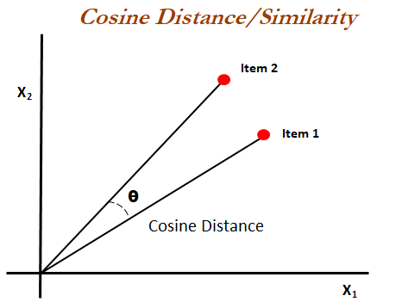



The cosine similarity formula is a mathematical expression used to determine the similarity between two vectors by measuring the cosine of the angle between them. It is most often applied in fields like natural language processing, information retrieval, recommendation systems, and machine learning, where data is represented as high-dimensional vectors. The general concept is based on the idea that the closer the angle between two vectors is to zero, the more similar they are.

In the formula, two vectors a and b are considered, and their similarity is measured using the cosine of the angle between them. The formula is written as cos(θ) = (a • b) / (||a|| ||b||), where "a • b" represents the dot product of the two vectors, and ||a|| and ||b|| are the magnitudes (or lengths) of the vectors. The dot product a • b is computed by multiplying corresponding components of the vectors and summing the results. The magnitude of a vector is the square root of the sum of the squares of its components. So the full formula becomes cos(θ) = (Σ aᵢbᵢ) / (√Σ aᵢ² × √Σ bᵢ²), where i ranges from 1 to n, the number of dimensions in the vectors.

The result of this formula is a value between -1 and 1. A cosine similarity of 1 means the vectors point in exactly the same direction and are perfectly similar. A value of 0 means the vectors are orthogonal or at a right angle, which implies no similarity. A value of -1 means they are diametrically opposed. However, in most practical applications involving data such as text or item ratings, the values are non-negative and the similarity ranges from 0 to 1.

Cosine similarity is particularly useful when the magnitude of the vectors should not affect the similarity result, only their orientation. For example, in document comparison, one document might be much longer than another but still have similar content. Cosine similarity ensures that the similarity is based on the shared distribution of words or features, not on the length or size of the documents.

In the context of a movie recommendation system, cosine similarity plays a key role. Movies are often represented as vectors, where each vector encodes various features of a movie, such as genres, cast, director, average rating, keywords, and user interactions. When a user watches or likes a particular movie, the system can compute the cosine similarity between the vector of that movie and vectors of other movies. The ones with the highest similarity scores are then recommended to the user. This way, the system can suggest movies that are closely aligned with the user's preferences without requiring explicit feedback or ratings for every single movie.

Similarly, users themselves can also be represented as vectors based on their past interactions with movies. A user vector might reflect the frequency or intensity of interest in different genres or themes. By computing cosine similarity between user vectors, the system can identify users with similar tastes and recommend to one user the movies liked by another similar user. This hybrid approach is often used in collaborative filtering methods where the goal is to leverage the wisdom of the crowd to make better recommendations.

Cosine similarity is also highly effective in text-based applications. In text mining, each document is typically represented as a vector using techniques such as term frequency-inverse document frequency (TF-IDF). The cosine similarity between two document vectors can then be used to determine how similar the two documents are in terms of content. This is useful for search engines, document clustering, duplicate detection, and semantic matching.

In sentiment analysis or question-answering systems, cosine similarity can help match user queries to the most relevant answers. For instance, if a user inputs a question, the system can compare the query vector with the vectors of previously answered questions or knowledge base entries. The entry with the highest cosine similarity score is likely the most relevant match and is presented to the user.

Another area where cosine similarity is beneficial is in clustering, such as K-means clustering for grouping similar items. Instead of using Euclidean distance, which is sensitive to magnitude, cosine similarity can be used to ensure that clusters are formed based on the orientation of data points. This helps in identifying groups of items that are structurally similar in terms of feature distribution, regardless of their scale.

Cosine similarity is computationally efficient, especially with sparse data. In real-world scenarios such as user-movie matrices or document-term matrices, most entries are zeros. This sparsity allows for fast computation of cosine similarity since the dot product and magnitude calculations involve only non-zero elements. Libraries in Python, such as Scikit-learn and SciPy, offer optimized functions to compute cosine similarity even for large-scale datasets.

In summary, the cosine similarity formula is a cornerstone of similarity measurement in vector space models. It allows us to quantify how similar two vectors are based on their direction, ignoring magnitude. This is especially important in applications where the amount of data (like the number of words in a document or the number of ratings given by a user) varies significantly. Cosine similarity is essential in recommender systems, document analysis, and clustering algorithms, where understanding relationships based on feature alignment is more valuable than absolute scale. Its simplicity, interpretability, and effectiveness make it one of the most widely used similarity metrics in the fields of data science and artificial intelligence.

**Snapshots Of Interface:**

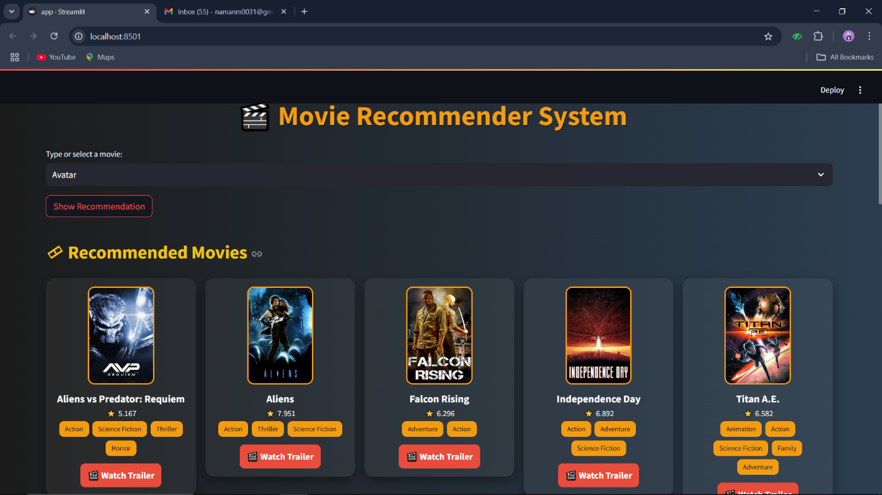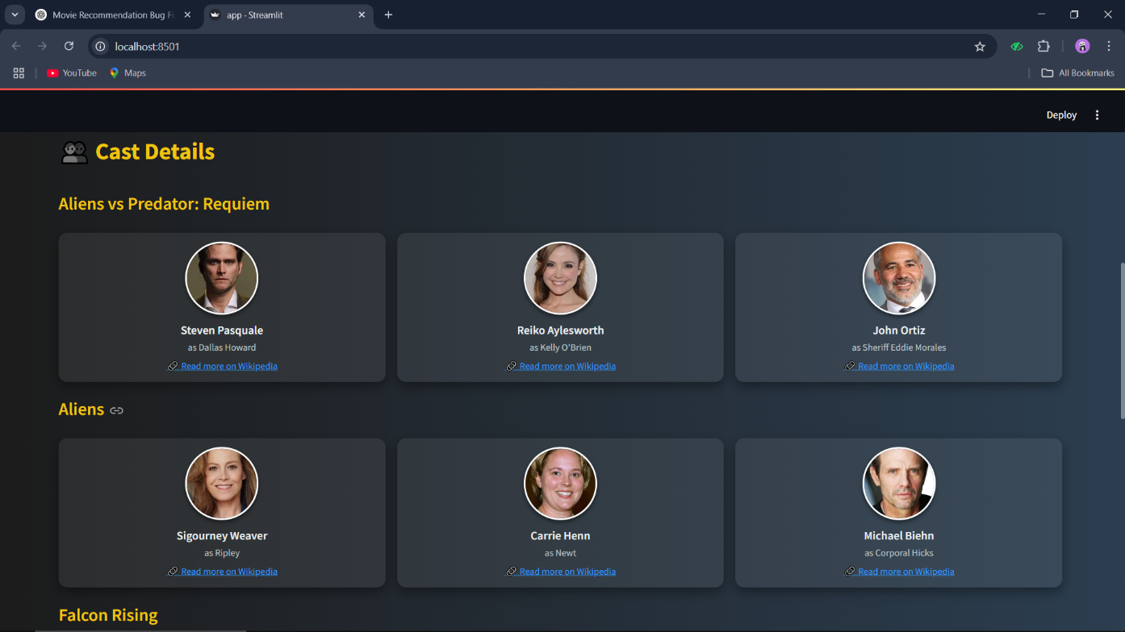

**CHAPTER 6**

# CONCLUSION

In conclusion, this project emphasizes the growing importance of recommendation systems, particularly in the realm of movies. By leveraging a content-based filtering approach, combined with vectorization and cosine similarity, the model effectively streamlines the movie selection process, providing users with personalized recommendations based on movie popularity and attributes. The use of vectorization techniques like TF-IDF enables the system to process large datasets efficiently, offering relevant suggestions while minimizing users' search time.

The project has successfully demonstrated that content-based recommendation systems can provide meaningful insights by analyzing textual and categorical data from movies. By evaluating elements such as genre, director, cast, plot descriptions, and keywords, the system builds a strong foundation for understanding user interests. While collaborative filtering and hybrid methods also offer significant benefits, this content-based approach shows promise in delivering precise recommendations tailored to user preferences. Furthermore, the system’s explainability makes it easier for developers and users to understand why a particular movie was recommended, thereby increasing transparency and user trust.

Moreover, integrating dynamic user behavior and contextual data can further enhance the recommendation process, making it more adaptive to changing preferences over time. Future work could involve extending the model by incorporating user feedback, temporal factors, and social influences, thereby improving the system's accuracy and making the movie recommendation process even more user-friendly. Incorporating deep learning models like neural collaborative filtering or transformers for textual understanding could also lead to even more refined and intelligent suggestions.

Challenges:

Cold-Start Problem for New Users:

One of the most significant challenges faced by content-based recommendation systems is the cold-start problem, particularly concerning new users. Since these systems rely heavily on past user interactions—such as ratings, views, or clicks—they struggle to generate accurate recommendations for users who have little to no historical data. Without sufficient input to understand a user’s preferences, the model cannot effectively align recommendations with their interests. This limitation can lead to irrelevant or generic suggestions during the initial phase of user engagement, potentially diminishing user satisfaction and retention. Addressing this issue often requires integrating auxiliary information such as demographic data, onboarding questionnaires, or leveraging hybrid systems that incorporate collaborative filtering or popularity-based suggestions to bridge the gap until more user-specific data is available.

Narrow Recommendations:

Another notable drawback of content-based systems is their tendency to produce narrow or repetitive recommendations. These models are designed to recommend content similar to what the user has already enjoyed, which can result in a "filter bubble" effect. This restricts content discovery and diversity, as users are rarely exposed to new or varied types of content outside their established preferences. Over time, this may lead to user fatigue or boredom. Enhancing diversity through exploration algorithms or by blending collaborative signals can mitigate this limitation and promote broader content engagement.

Future Scope:

To enhance the recommendation system in the near future, addressing the cold-start problem and improving recommendation diversity will be crucial. A promising solution is the adoption of a hybrid approach that combines content-based filtering with collaborative filtering or deep learning models. Content-based filtering excels at using item features to suggest similar content, while collaborative filtering leverages user-item interactions, allowing the system to learn from the behavior of similar users. By blending these techniques, the system can compensate for the weaknesses of each, such as the lack of historical data in cold-start scenarios or the limited diversity caused by strict content matching.

Additionally, the integration of deep learning models, such as neural collaborative filtering or recurrent neural networks, can significantly boost the system’s ability to understand complex patterns in user behavior and preferences. These models are capable of capturing subtle nuances in user interactions, leading to more personalized and adaptive recommendations.

Furthermore, refining the evaluation strategy by incorporating both explicit feedback (e.g., ratings or reviews) and implicit feedback (e.g., clicks, watch time, or browsing patterns) can enhance prediction accuracy. Implicit signals provide valuable insights into user interest, even when direct input is lacking. Together, these enhancements can make the system more robust, accurate, and user-centric.

In this way, this project is a proof of feasibility and efficacy of the content-based approach to movie recommendations and serves to widen the areas of future work that could together form a much more powerful and holistic recommendation engine.

**CHAPTER 7**

# REFERENCE

[1] Goyani, Mahesh; Chaurasiya, Neha. "A Review of Movie Recommendation System: Limitations, Survey and Challenges". ELCVIA : Electronic Letters on Computer Vision and Image Analysis.

Vol. 19 No. 3 (2020), p. 18-37 DOI 10.5565/rev/elcvia.1232 https://ddd.uab.cat/record/232276

[2] J. Zhang, Y. Wang, Z. Yuan and Q. Jin, "Personalized real-time Movie Recommendation System: Practical prototype and evaluation," in Tsinghua Science and Technology, vol. 25, no. 2, pp. 180-191, April 2020, doi: 10.26599/TST.2018.9010118.

[3] R. Ahuja, A. Solanki and A. Nayyar, "Movie Recommender System Using K-Means Clustering AND K-Nearest Neighbor," 2019 9th International Conference on Cloud Computing, Data Science & Engineering (Confluence), Noida, India, 2019, pp. 263-268, doi: 10.1109/CONFLUENCE.2019.8776969.

[4] Choudhury, S.S., Mohanty, S.N. & Jagadev, A.K. Multimodal trust based recommender system with machine learning approaches for movie recommendation. Int. j. inf. tecnol. 13, 475–482 (2021). https://doi.org/10.1007/s41870-020-00553-2

[5] S. Sahu, R. Kumar, M. S. Pathan, J. Shafi, Y. Kumar and M. F. Ijaz, "Movie Popularity and Target Audience Prediction Using the Content-Based Recommender System," in IEEE Access, vol. 10, pp. 42044-42060, 2022, doi: 10.1109/ACCESS.2022.3168161.

[6] Gopal Behera, Neeta Nain, Collaborative Filtering with Temporal Features for Movie Recommendation System, Procedia Computer Science, Volume 218, 2023, Pages 1366-1373, ISSN 1877-0509, https://doi.org/10.1016/j.procs.2023.01.115.

[7] M. Gupta, A. Thakkar, Aashish, V. Gupta and D. P. S. Rathore, "Movie Recommender System Using Collaborative Filtering," 2020 International Conference on Electronics and Sustainable Communication Systems (ICESC), Coimbatore, India, 2020, pp. 415-420, doi: 10.1109/ICESC48915.2020.9155879.

[8] Zahra ZamanzadehDarban, Mohammad Hadi Valipour, GHRS: Graph-based Hybrid recommendation system with application to movie recommendation, Expert Systems with Applications, Volume 200, 2022, 116850, ISSN 0957-4174, https://doi.org/10.1016/j.eswa.2022.116850.

[9] Priyanshu Modi, Atul Kumar, Bhaskar Kapoor - Filmview: A Review Paper on Movie Recommendation Systems, JUN 2023 | IRE Journals | Volume 6 Issue 12| ISSN: 2456-8880.

[10] N Pavitha, Vithika Pungliya, Ankur Raut, Roshita Bhonsle, Atharva Purohit, Aayushi Patel, R Shashidhar - Movie recommendation and sentiment analysis using machine learning - Global Transitions Proceedings 3 (2022) 279–284

[11] Yeole Madhavi B.1, Rokade Monika D.2, Khatal Sunil S.3 - Movie Recommendation System using Content based Filtering - Vol-7 Issue-4 2021 IJARIIE-ISSN(O)-2395-4396-14954

[12] Dr. Ganesh D, Yash Bhansali - Movie Recommendation System Using Content- Based Filtering - 2022 IJCRT | Volume 10, Issue 4 April 2022 | ISSN: 2320-2882